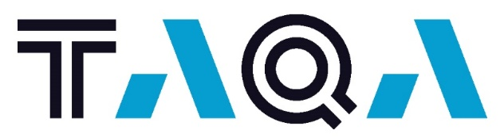
Powering a Thriving Future

Job Title: Apprentice Mechanic/Millwright ~ RQ 23-93~
Are you interested in being part of a team that believes in the pursuit of excellence, conducting work in a safe and sustainable manner and being courageous and creative in everything we do?
TAQA North currently has an opening for the position of Apprentice Mechanic/Millwright. Reporting to the Maintenance Foreman, the Apprentice Mechanic/Millwright will perform maintenance/repairs on all rotating equipment in the Central Operating area.

The successful candidate must live within the Grande Prairie area to be available for call outs.
Your Key Responsibilities:
- Assisting the Journeyman mechanics/millwrights in day-to-day maintenance on a variety of rotating equipment (engines, compressors, pumps, etc.)
- Managing the day-to-day operation of a field service truck when deemed competent
- Completing daily work orders, this includes repair and maintenance of all rotating equipment
- Completing scheduled Preventative Maintenance work orders
- Assisting with planning and coordinating mechanical activities during turnarounds and outages
- Working with Operations and Maintenance to commission new and existing equipment
- Maintaining effective communication with Operations and complying with all operation and safety procedures
- Assisting on call mechanics when needed for callouts (evenings and weekends)

Your Qualifications:
- 2nd, 3rd, or 4th year Apprenticeship in either Heavy Equipment technician or Millwright Trades.
- Minimum 1-2 years Oil and Natural Gas Experience
- Experience with Waukesha, Cat, Cummins, White Superior, Arrow Engines
- Experience with reciprocating and screw compressors, pumps, air compressors, etc
- Safety and quality minded attitude, a self starter with a high level of attention to detail
- Willingness and ability to support other TAQA maintenance staff and work overtime hours if needed
- Candidates must live in the Grande Prairie area to be available for call outs
Benefits of Working at TAQA North:
- Great Team Environment
  - We do what is right for our environment, community and people
  - We believe in equal employment opportunities and strive for a diverse workplace
  - We celebrate and recognize our people

- Highly Competitive Benefits Program
  - TAQA North offers a comprehensive benefits program. In addition to extended health, dental and vision, we offer a group savings plan, healthcare spending account and wellness plan
  - We respect work/life balance and offer a robust vacation program including flex days
  - We believe in giving back to our communities and offer a charity matching program

- Growth Potential
  - TAQA is a global organization with operations in numerous locations around the world including the UK, Netherlands, Iraq, Ghana and Abu Dhabi
  - TAQA North has field operations in Alberta and Saskatchewan that deliver production of approximately 75,000 barrels of oil equivalent/day with the aim to grow to 90,000 barrels of oil equivalent/day

- Sustainability
  - TAQA aims to be a low carbon power and water champion
  - TAQA North is committed to being a safe and environmentally responsible producer
  - TAQA North uses Acid Gas Injection (AGI) at the Crossfield plant to reduce greenhouse gas emissions
TAQA is an Abu Dhabi based company that provides water and energy to communities around the world with an oil and gas sector. When you join TAQA North, you will be joining a company that believes in collaboration, supporting professional development and being active members in the communities where we operate. We strive to create a work environment that is productive and profitable as well as stimulating and enjoyable.
Closing Date: May 9, 2024 To apply please visit: www.taqa.com/careers

